Instructions for using your Clio Coded Precedents

Contents
Creating Custom Fields in Clio 2
Creating Matter for Couples 7
Creating Firm Address(es) to align with Clio Templates 10
Populating Client Reference Number into documents 12

Creating Custom Fields in Clio

Step 1: Click on DASHBOARD (left hand side, at top of screen – see below)
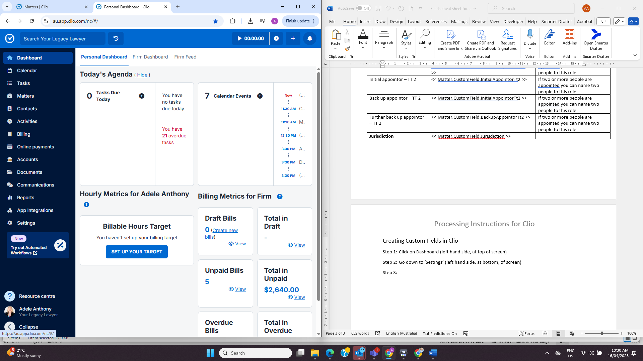
Step 2: Go down to SETTINGS (left hand side, at bottom, of screen – see below)

Step 3: Click on ‘Custom Fields’ (see below)
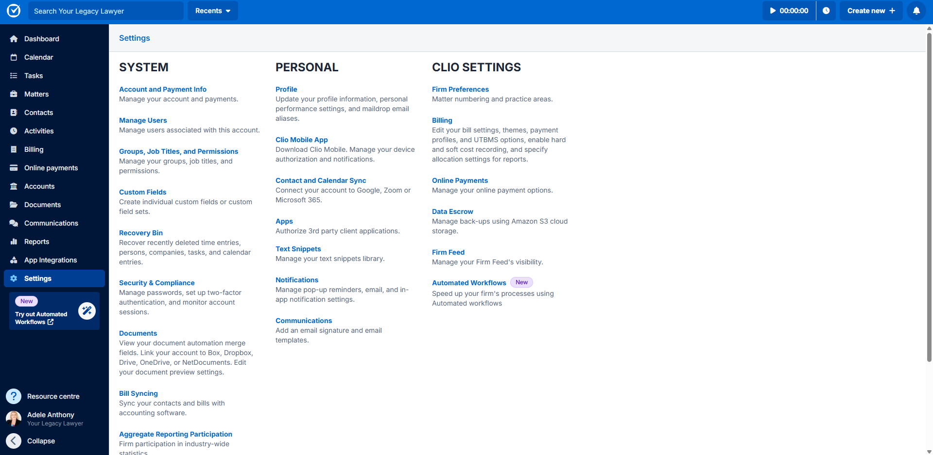

Step 4: Click on ‘Add’ (top right hand corner of screen – see below)
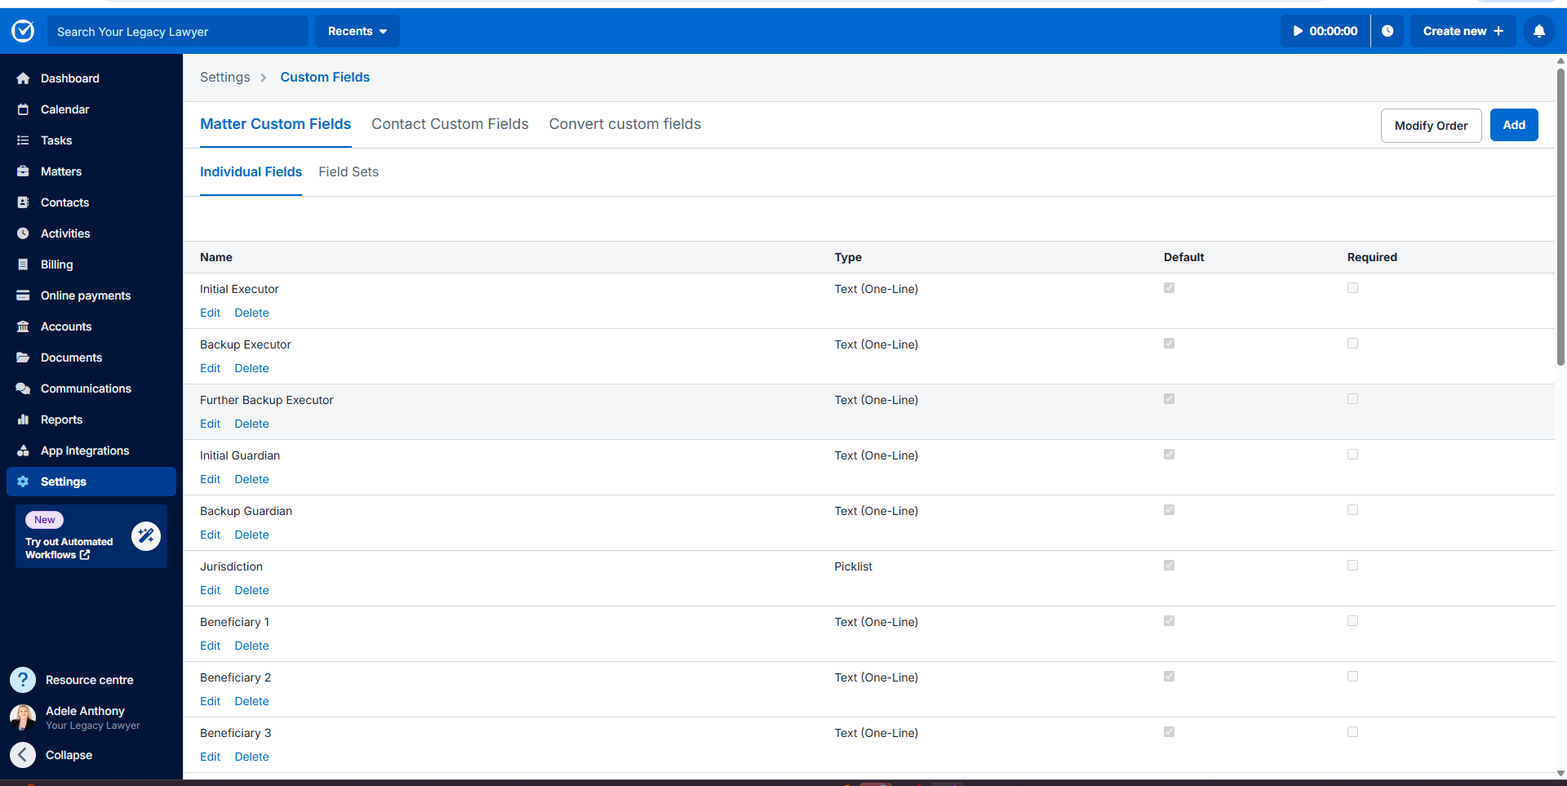
Step 5: Type Name exactly as per the below list so the codes are created exactly as depicted in the first column. We recommend you copy and paste rather than type them, so they are an exact replica.
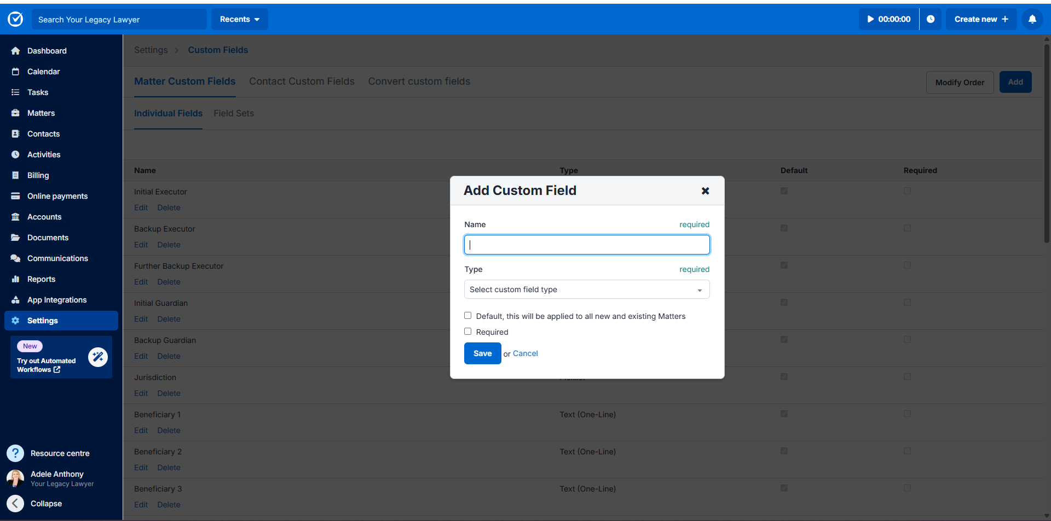
Use the below list to create your custom fields:

Custom field to create (copy from this column when creating your custom fields) | Clio code | Tips/Comments
InitialExecutor | << Matter.CustomField.InitialExecutor >> | If two or more people are appointed you can name two people to this role.  If entering more than one person in each field, make sure to use commas and ‘and’ so they appear in the documents correctly.
BackupExecutor | << Matter.CustomField.BackupExecutor >>
FurtherBackupExecutor | << Matter.CustomField.FurtherBackupExecutor >>
InitialGuardian | << Matter.CustomField.InitialGuardian >>
BackupGuardian | << Matter.CustomField.BackupGuardian >>
Beneficiary1 | << Matter.CustomField.Beneficiary1 >> | Only complete for an Individual client or a simple will – this is the beneficiary who will be entitled to the personal items and the residual estate (if there is no TT)
Beneficiary2 | << Matter.CustomField.Beneficiary2 >>
Beneficiary3 | << Matter.CustomField.Beneficiary3 >>
CalamityBeneficiary1 | << Matter.CustomField.CalamityBeneficiary1 >> | Only complete for an Individual client or a simple will where the calamity beneficiaries are not parents/children of testators
CalamityBeneficiary2 | << Matter.CustomField.CalamityBeneficiary2 >>
CalamityBeneficiary3 | << Matter.CustomField.CalamityBeneficiary3 >>
FinancialAdviserName | << Matter.CustomField.FinancialAdviserName >> | Can put in financial adviser name and firm
Jurisdiction | << Matter.CustomField.Jurisdiction >>
Testamentary Trust 1 | If a single TDT, only complete fields for TT 1 and leave TT 2 blank
NominatedBeneficiaryTt1 | << Matter.CustomField.NominatedBeneficiaryTt1 >> | If a single TDT, you can leave this field blank if the testator’s children are the nominated beneficiaries for the TT  If a multi TDT, insert the person for whom TT 1 is earmarked
InitialTrusteeTt1 | << Matter.CustomField.InitialTrusteeTt1 >> | If two or more people are appointed you can name two people to this role.  If entering more than one person in each field, make sure to use commas and ‘and’ so they appear in the documents correctly.
BackupTrusteeTt1 | << Matter.CustomField.BackupTrusteeTt1 >>
FurtherBackupTrusteeTt1 | << Matter.CustomField.FurtherBackupTrusteeTt1 >>
InitialAppointorTt1 | << Matter.CustomField.InitialAppointorTt1 >>
BackupAppointorTt1 | << Matter.CustomField.BackupAppointorTt1 >>
FurtherBackupAppointorTt1 | << Matter.CustomField.FurtherBackupAppointorTt1 >>
Testamentary Trust 2
NominatedBeneficiaryTt2 | << Matter.CustomField.NominatedBeneficiaryTt2 >> | If a multi TDT, insert the person for whom TT 2 is earmarked
InitialTrusteeTt2 | << Matter.CustomField.InitialTrusteeTt2 >> | If two or more people are appointed you can name two people to this role.  If entering more than one person in each field, make sure to use commas and ‘and’ so they appear in the documents correctly.
BackupTrusteeTt2 | << Matter.CustomField.BackupTrusteeTt2 >>
FurtherBackupTrusteeTt2 | << Matter.CustomField.FurtherBackupTrusteeTt2 >>
InitialAppointorTt2 | << Matter.CustomField.InitialAppointorTt2 >>
BackupAppointorTt2 | << Matter.CustomField.BackupAppointorTt2 >>
FurtherBackupAppointorTt2 | << Matter.CustomField.FurtherBackupAppointorTt2 >>

Step 6: In ‘Select custom field type’ drop down select “Text One Line” and then select “Default” and then hit SAVE.
Step 7: Go back to DASHBOARD.
Step 8: Go into SETTINGS.
Step 9: Go into Documents (see below)
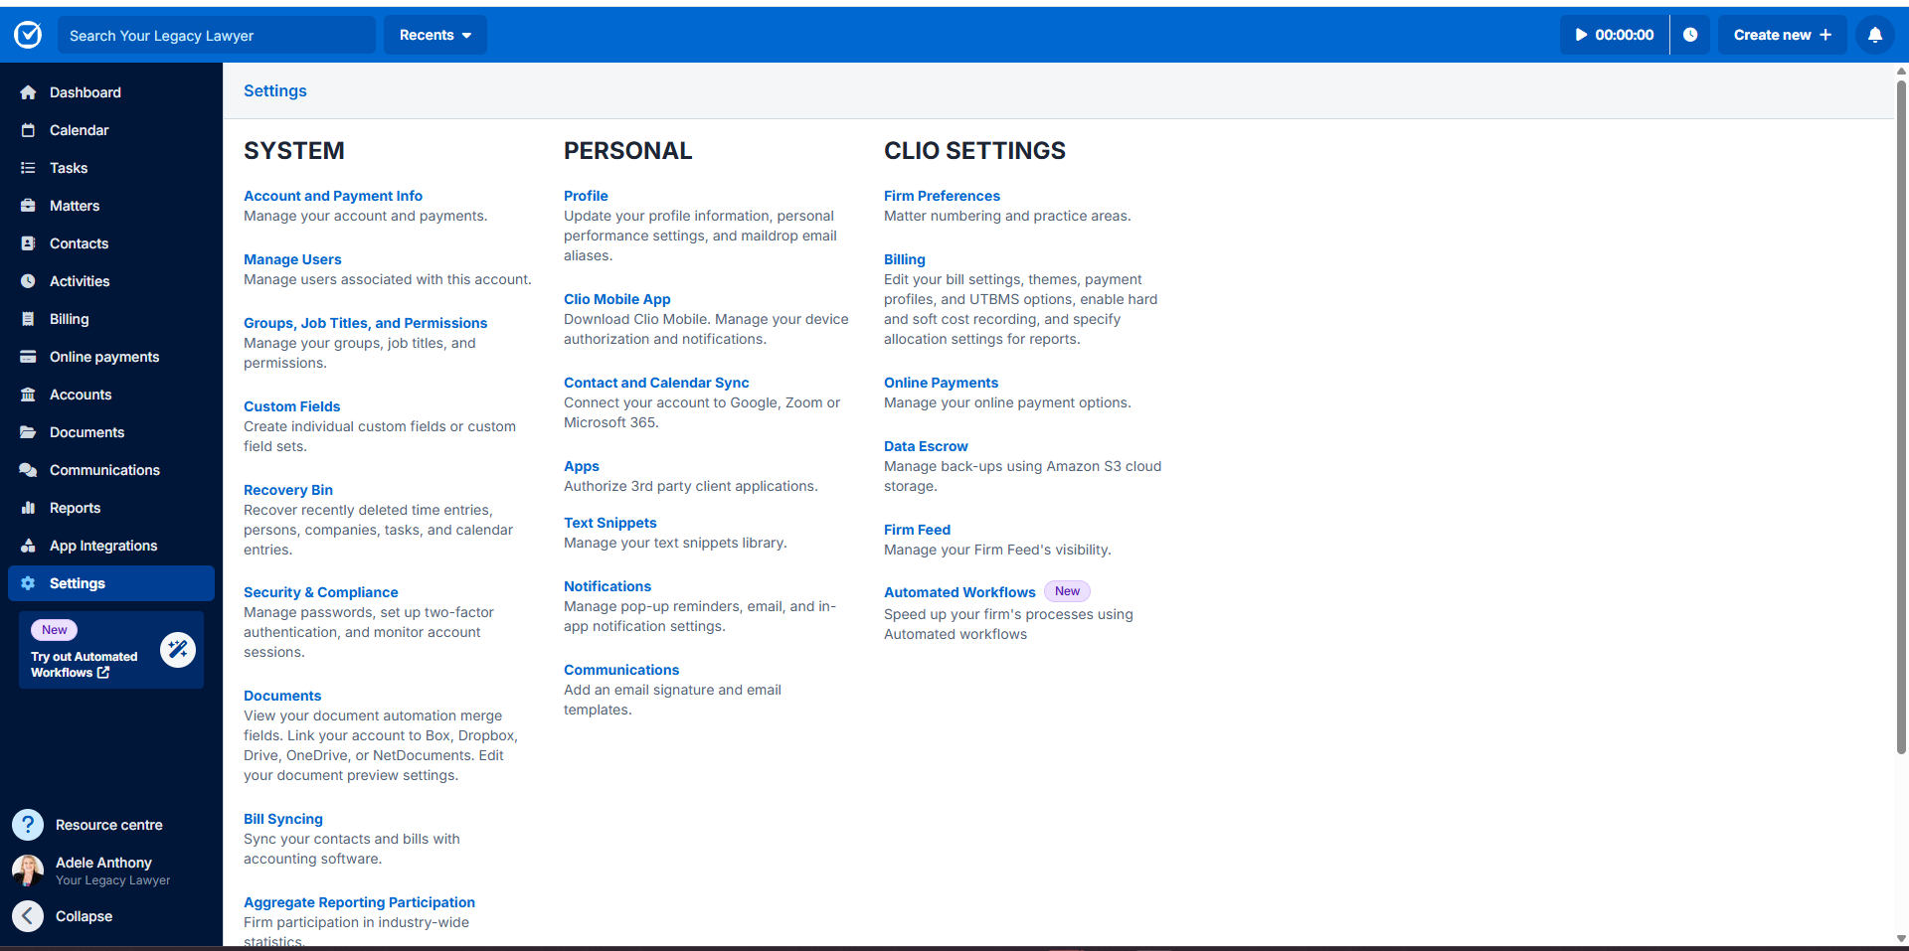
Step 10: Here you will see all your custom fields as well as ones created by Clio.
Step 11: Check that the custom fields are exactly as per column 1 in the list above otherwise they will not populate the documents correctly.
*You will not have to create the custom fields again. The fields created will be available for all existing and future matters.
**In every matter dashboard (see below), you can see the custom fields available. If you click on Edit Matter, you will be able to enter the details of the applicable persons. You can enter more than one person in each field, make sure to use commas and ‘and’ so they appear in the documents correctly.
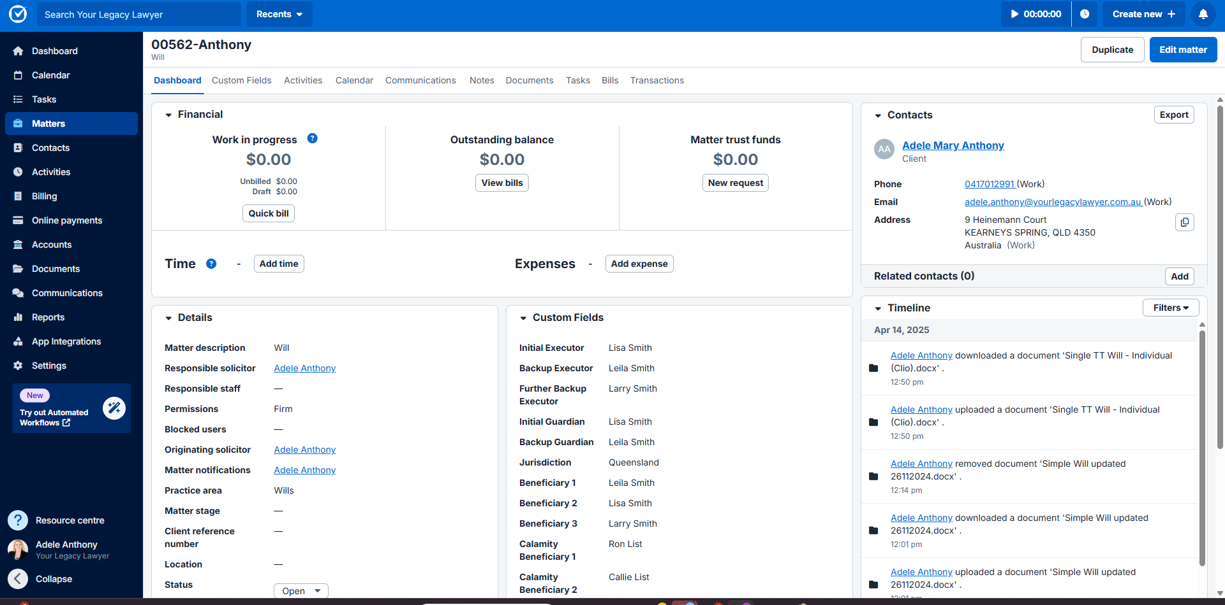

Creating Matter for Couples

Step 1: Click on CREATE NEW (right hand side, at top of screen – see below)
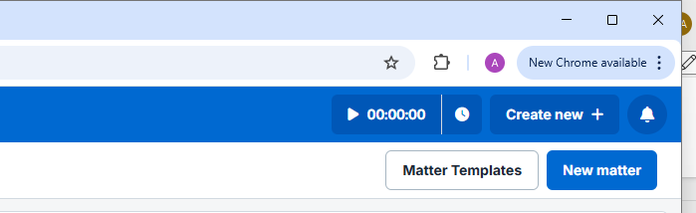

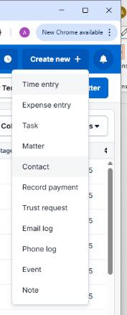
Step 2: In drop-down, click on CONTACT – (see below)

Step 3: Enter in all client’s (MR) information and press SAVE – (see below) - **REPEAT THIS STEP FOR MRS
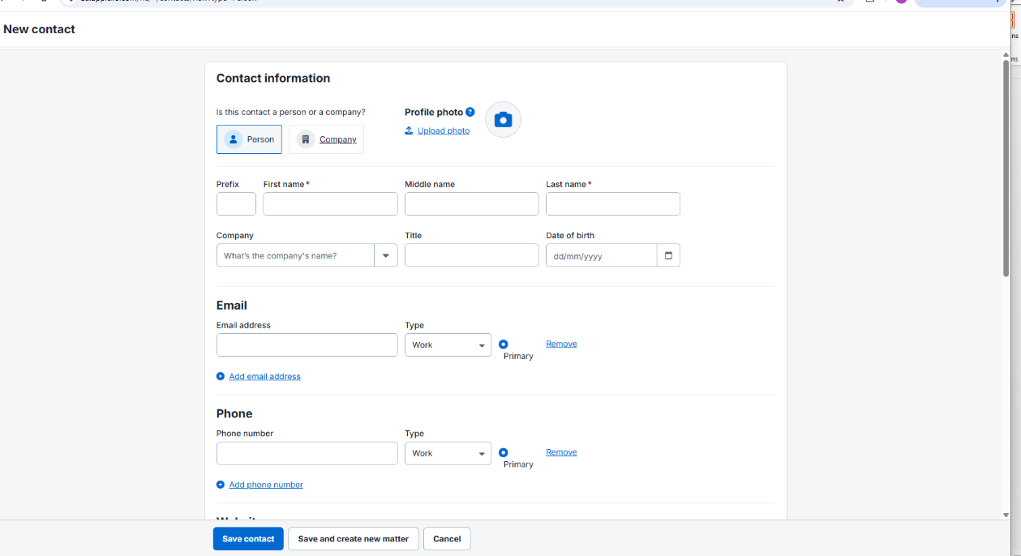

Step 4: Click on CREATE NEW as per above at Step 1
Step 5: In drop-down, click on CONTACT.
Step 6: Instead of clicking on ‘Person’, this time click on ‘Company’ (see below).
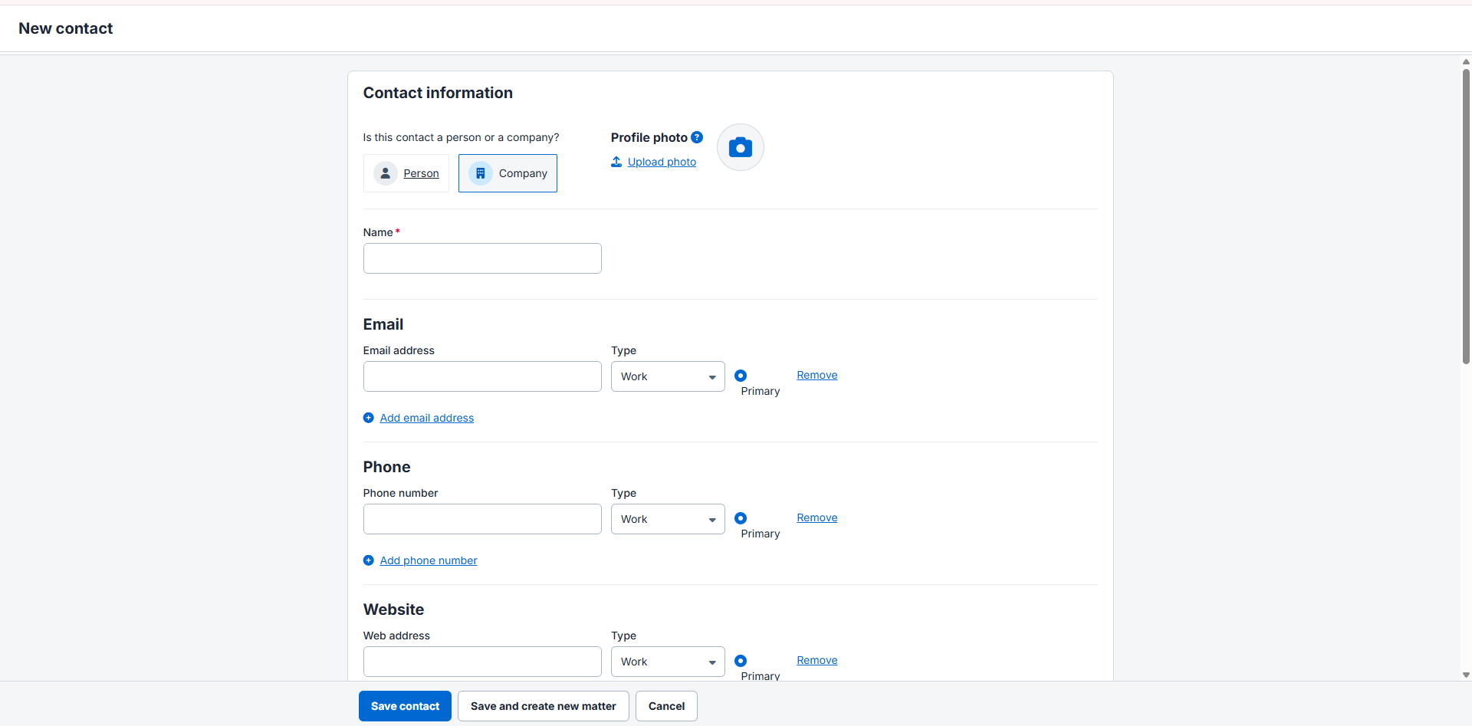
Step 7: Complete the section ‘Name’ – type in Mister’s Full Name – add a space and type in the word ‘and’ – add a space and then type in Mrs Full Name.
Step 8: Enter in all Matter details (see below)
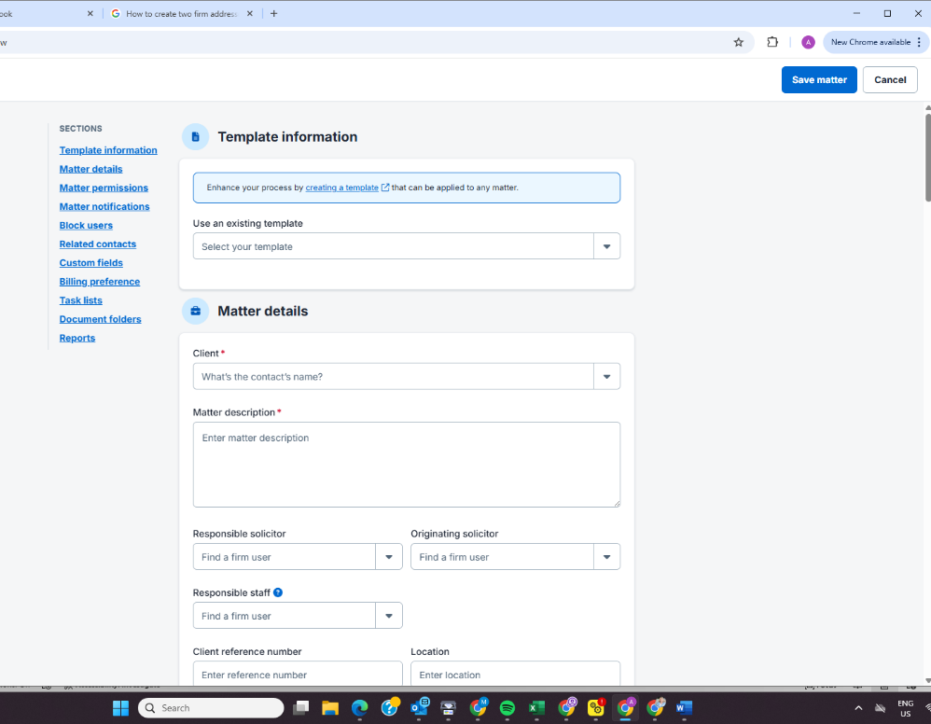

Step 9: Scroll down to the section before ‘Custom Fields’ headed ‘Related Contacts’.
Step 10: Click on the drop-down arrow in this section headed ‘Contact’ (see below).
Select your Mr for the matter and in the section headed ‘Relationship’ next to ‘Contact’, type in Mr
Replicate for Mrs
This adds Mr and Mrs to a Matter and will create fields for both. Press SAVE.
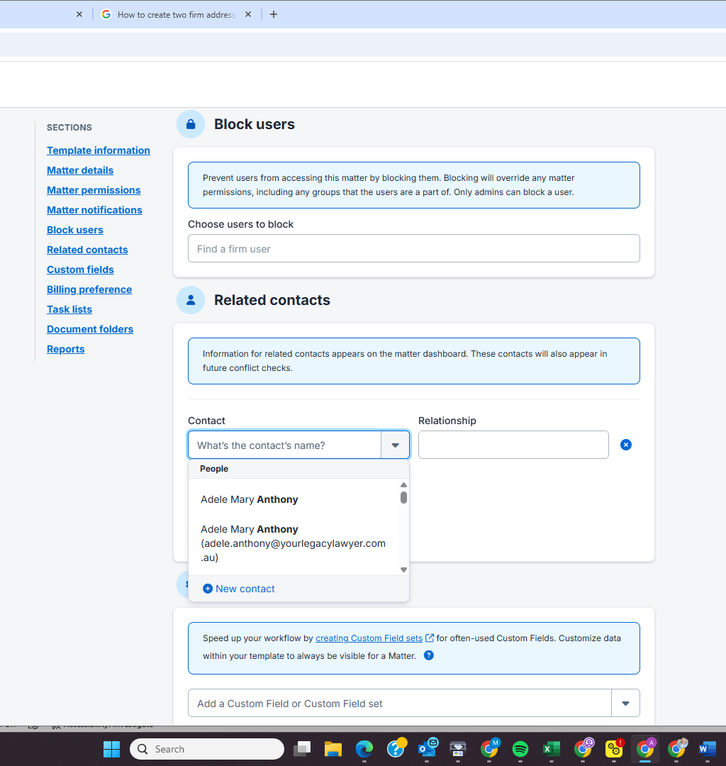

Creating Firm Address(es) to align with Clio Templates

Step 1: Click on SETTINGS (left hand side, at bottom of screen – see below)
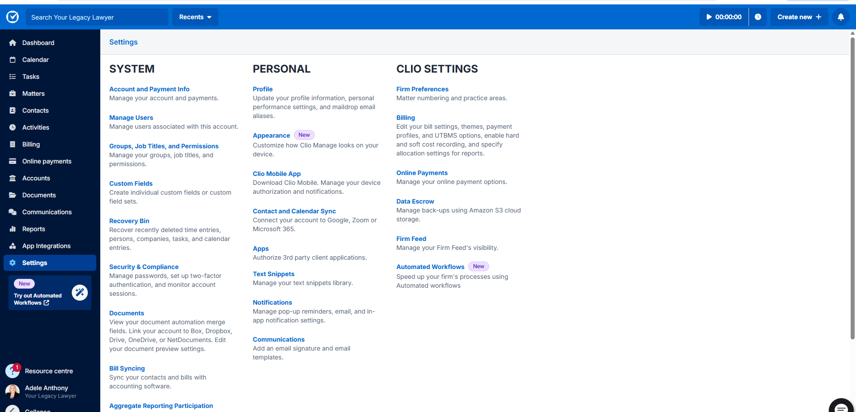
Step 2: Click on Profile >> Your Information >> (see below) and enter your PO Box address here. This creates the code << User.Address >> ***which is the field used in our template letters.
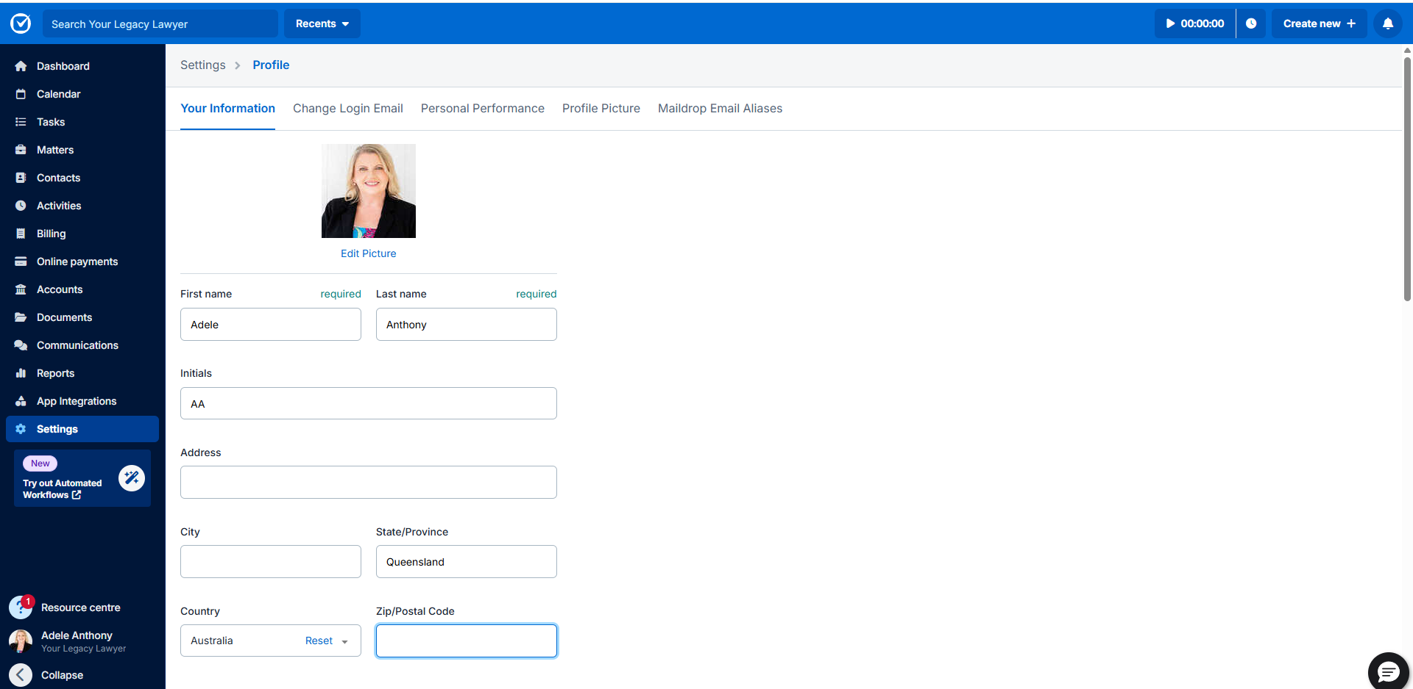

** THIS IS DIFFERENTIATED FROM** ‘SETTINGS’ (left hand side, at bottom of screen – see below)
ACCOUNT & PAYMENT INFO - where you are asked to fill in your address, put in your street address in both sections (see below) – the information you fill in here creates the code << Firm.Address >>
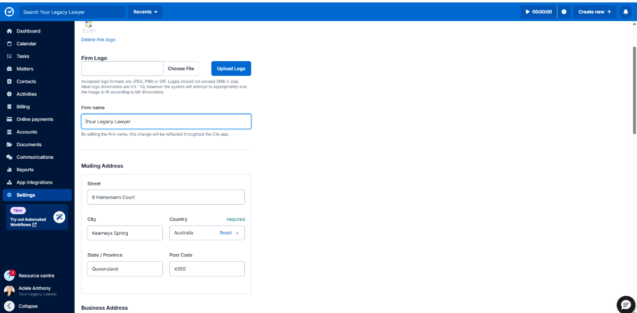

Populating Client Reference Number into documents

Step 1: Once a matter has been created (either individual or couple), you have to edit the matter – click on the ‘Edit matter’ button on the top right hand of the screen (see below)
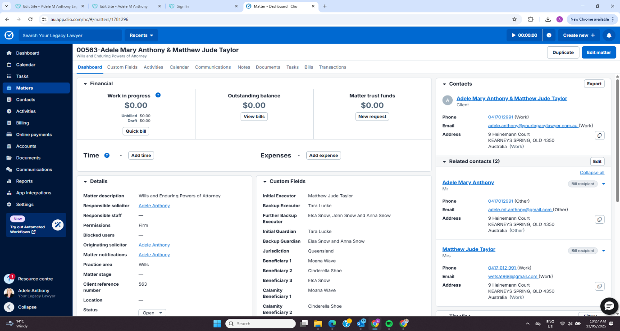
Step 2: Enter the number which appears (in bold) on the top left-hand corner of the screen (see below) into the ‘Client reference number’ field – this will now populate into your documents
